1. **Differentiae between global and local page replacements.**

| **Key Point** | **Global Page Replacement** | **Local Page Replacement** |
| --- | --- | --- |
| **Frame Selection** | Chooses a replacement frame from **any process’s frames** | Chooses a replacement frame from **its own allocated frames only** |
| **Frame Stealing** | Allows **stealing frames** from other processes | **No frame stealing**; process uses only its own frames |
| **Example** | Process A can take a frame from Process B if needed | Process A must choose a victim frame from its own frames, even if B has free frames |
| **Performance Impact** | Can **maximize system throughput**, but may cause **process thrashing** | **Better isolation**; avoids interference but may **underutilize available memory** |
| **Fairness** | May lead to **unfair allocation** among processes | Promotes **fair and predictable** performance per process |

1. **What is file? Mention some important file attributes.**

A file is a named collection of related information that is recorded on secondary storage. Some important attributes of a file are **Name, Type, Location, Size, Access control information, Time, Date and User identification.**

1. **Specify major file operations.**

The major file operations are,

Creating a file, Writing a file, Reading a file, Repositioning within a file, Deleting a file and Truncating a file.

4.Mention common file types with their extension and functions.

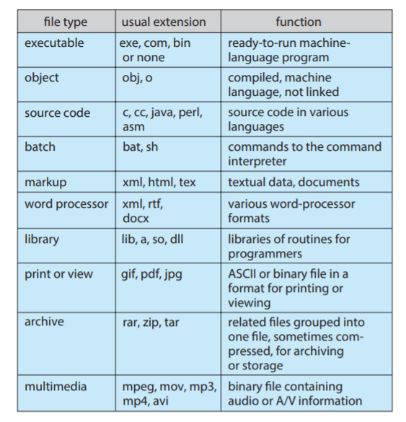

1. **Differentiate the various file access methods.**

**Sequential access** - Information in the file is processed in order.

one record after the other. This access is based on a tape model of file.

**Direct or relative access** – This allows programs to read and write records rapidly in any order. This access is based on a disk model of file.

**Indexed sequential access** – This uses index files to point to the actual file blocks.

1. **What are the operations performed on a directory?**

The operations performed on a directory are,

Search for a file, Create a file, Delete a file, List a directory, Rename a file and Traverse the file system.

1. **Specify the various directory structures.**

**Single-level directory** – All files are contained in the same directory. Here the limitation is files require unique names and also naming and grouping problem

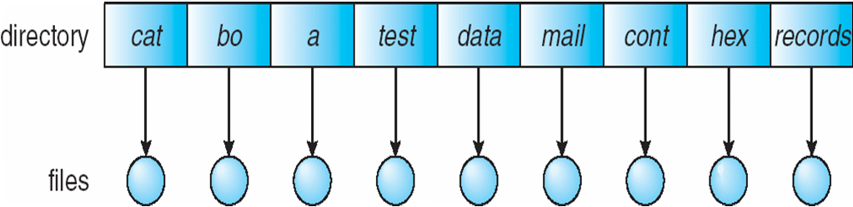

**Two-level directory** – Separate directory is created for each user. Within each user file directory, the file names should be unique. And so Path name, same file name for different user,Efficient searching,No grouping capability

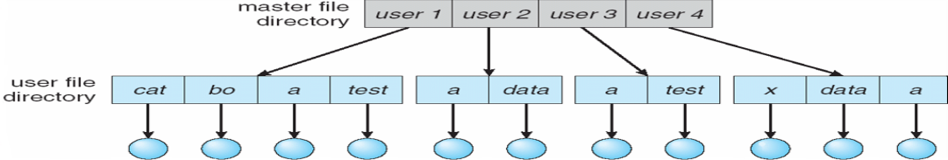

**Tree-structured directory** – A directory contains a set of files or subdirectories,If dict deletes list  dangling pointer,backpointer-delete all pointer varible size (using daisy chain organization).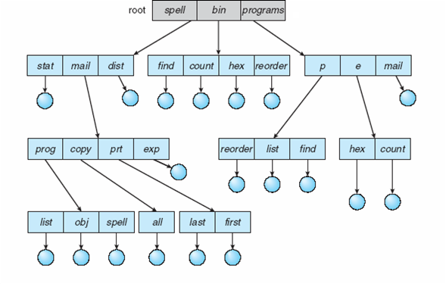

**Acyclic-graph directory** - A directory contains a set of files or subdirectories ,

efficient searching and grouping capablity.

. 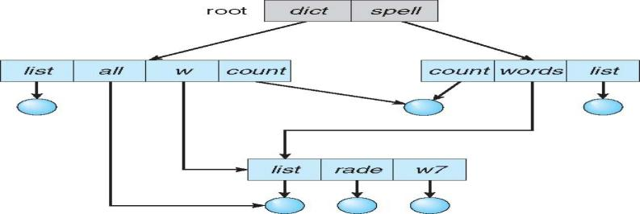

**General-graph directory** – Same as acyclic-graph directory with cycles allowed to exist

File A uses blocks 3 → 5 → 8; FAT[3]=5, FAT[5]=8, FAT[8]=EOF.

1. **Mention the different types of operations controlled for protection.**

Different types of operations controlled are Read, Write (modifying the file), Execute, Append (writing new information at the end of file), Delete and List (listing the name and attributes of a file)

1. **What is FAT?**

FAT stands for File Allocation Table.

FAT is MS-DOS (Microsoft-Disk Operating System) file system file descriptor.

The FAT is kept in memory for quick access during file operations.

Eg-File A uses blocks 3 → 5 → 8; FAT[3]=5, FAT[5]=8, FAT[8]=EOF.

1. **Specify various file allocation methods.**

**Contiguous allocation** –

* requires each file to occupy a set of contiguous blocks in the disk.
* Advantage simple to implement
* disadvantage is internal fragmentation problem
* 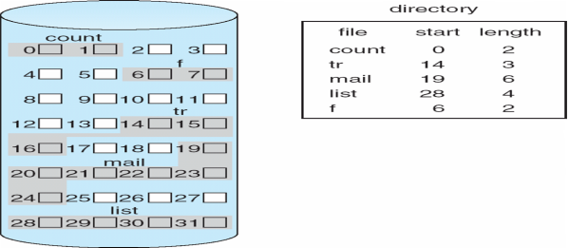

**Linked allocation** –

* Each file is a linked list of disk blocks.
* Advantage - no need to declare the sixe of a file during creation
* Disadvantage- inefficient to support direct access file, space required for the pointer and dangling pointers.
* 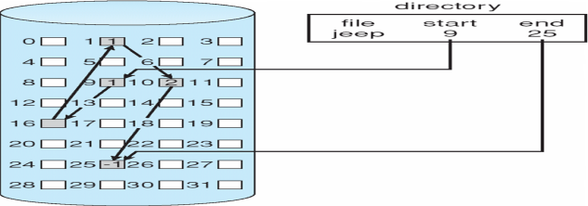

**Indexed allocation –**

* Each file has its own index block, it is an array of disk block addresses. **Advantage**- no dangling pointer and **disadvantage** - suffers from wasted space. Need index table ,Random access
* Dynamic access without external fragmentation, but have overhead of index block
* 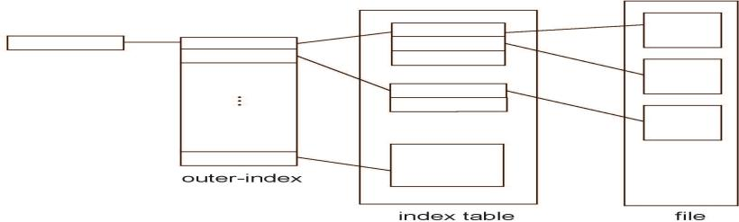

1. **What is meant by free space management? Mention the various techniques used.**

* Free space management requires keeping track of free disk space in the system.
* For this a free-space list is maintained.
* This list records all disk blocks that are free.
* i.e. disks that are not allocated to some file or directory.
* The various techniques used are bit vector, Linked list, Grouping and Counting.

1. **Define the terms seek time, rotational latency and disk bandwidth.**

**seek time** - the time for the disk arm to move the heads to the cylinder contain the desired sector.

**rotational latency** - the time waiting for the disk to rotate, bring the desired sector to the disk head.

**disk bandwidth** - the total number of bytes transferred.

It is divided by the total time between the first request for service & the completion of last transfer.

1. **What is the need for disk scheduling?**

In a multiprogramming system with many processes, the disk queue may have several pending requests, which are to be serviced with minimum time. For this the disk scheduling is needed. The pending requests are scheduled in an order to minimize the disk bandwidth.

1. **Mention the various disk scheduling algorithms.**

First Come First Served (FCFS) scheduling. Shortest Seek-Time First (SSTF) scheduling, SCAN scheduling, Circular SCAN (C-SCAN) scheduling, LOOK scheduling, circular LOOK (C-LOOK) scheduling.

1. **Differentiate between SCAN and LOOK scheduling?**

| **Key Point** | **SCAN Scheduling** | **LOOK Scheduling** |
| --- | --- | --- |
| **Movement Pattern** | Disk arm moves **to the end** of the disk in each direction, servicing requests on the way. | Disk arm moves **only up to the last request** in each direction. |
| **Efficiency** | May result in **extra head movement** beyond last request. | **Reduces unnecessary movement**, improving performance. |
| **Direction Handling** | Services in one direction until the end, then **reverses direction**. | Same as SCAN, but stops at **last request**, not end of disk. |
| **Example** | Goes from 0 to 199, servicing requests, then reverses. | Goes from current position to last request (e.g., 0 to 120), then reverses. |
| **Also Known As** | Sometimes called **“Elevator Algorithm”**. | Sometimes called **“Optimized SCAN”**. |

1. **What is swap-space management?**

* Virtual memory uses dish space as an extension of main memory.
* Swap-space management is a low-level task of operating system
* It is used to provide the best throughput for the virtual memory system.
* This manages the swap space in an efficient manner to improve the system performance.

1. **What is BIOS?**

BIOS stands for Basic Input/ Output System.

It is a collection of programs stored in computer ROM.

These are called by conventional software .

1. **What is Kernel?**

Kernel is the part of the operating system that is implemented to execute basic processor and memory management functions.

Kernel is software which runs in the supervisor mode.

1. **What is the use of inode?**

inode is the file descriptor in a UNIX or LINUX system. This is used to maintain file information and to know where the file is located in the secondary storage.

1. **Define buffering?**

* store data in memory while transferring between devices
* To cope with device speed mismatch
* To cope with device transfer size mismatch
* To maintain “copy semantics” and **double buffering** - two copies of data

1. **Catching**

* faster device holding copy of data
* Always just a copy and key to perfomance
* Sometimes combined with buffering

1. **Spooling -**holds output for a device ,it serve only one request at a time,eg-printing
2. **Device resevation-**provides exclusive access to a device
3. **Define direct memory access(DMA)?**

|  |  |
| --- | --- |
| **Definition** | DMA allows devices to transfer data to/from memory **without CPU intervention**. |
| **Efficiency** | It **frees the CPU** from handling data transfer tasks directly. |
| **Controller** | A **DMA controller** manages the memory access between device and RAM. |
| **Example** | A network card uses DMA to transfer packets directly to RAM. |

1. **define interrupt?**Interrupt mechanism also used for exceptions and soTerminate process, crash system due to hardware error.Page fault executes when memory access error.
2. **Define mass storage management**

|  |  |
| --- | --- |
| **1. Definition** | Refers to non-volatile storage like **magnetic disks and solid-state drives**. |
| **2. Hierarchical Access** | Data is organized and accessed using **multiple levels (disk → block → byte)**. |
| **3. Example** | Hard disk drives (HDDs) and SSDs are part of the mass storage structure. |

1. **Define polling**

|  |  |
| --- | --- |
| **1. Definition** | Polling is a method where CPU **repeatedly checks** device status. |
| **2. CPU Involvement** | It **wastes CPU cycles** while waiting for device readiness. |
| **3. Example** | Continuously checking a printer’s status before sending data. |

1. **define storage are network**

|  |  |
| --- | --- |
| **1. Definition** | SAN is a **high-speed network** connecting storage devices to servers. |
| **2. Scalability** | Allows **centralized, scalable** storage access for multiple systems. |
| **3. Example** | Datacenters use SAN to connect multiple servers to a shared storage pool. |

**28.define disk scheduling?**

|  |  |
| --- | --- |
| **1. Definition** | Disk scheduling determines the **order** in which I/O requests are served. |
| **2. Goal** | Aims to **minimize seek time** and improve system performance. |
| **3. Example** | Algorithms like **FCFS**, **SSTF**, **SCAN**, and **LOOK** handle scheduling. |

**Comparison table of fcfs,sjf,srtn,scan,look,c-scan,c-look.**

| **Point** | **FCFS (First Come First Serve)** | **SJF (Shortest Job First)** | **SRTN (Shortest Remaining Time Next)** | **SCAN** | **C-SCAN** | **LOOK** | **C-LOOK** |
| --- | --- | --- | --- | --- | --- | --- | --- |
| **1. Type** | Non-preemptive CPU scheduling | Non-preemptive CPU scheduling | Preemptive CPU scheduling | Disk | Disk | Disk | Disk |
| **2. Selection Basis** | Order of arrival | Shortest burst time | Least remaining burst time | Services in one direction to disk end | Moves in one direction then jumps | Services until last request then reverses | Jumps after last request without full sweep |
| **3. Starvation** | No starvation | May cause starvation | High starvation risk for long processes | Less starvation than SSTF | Reduces starvation | Less starvation | Minimizes starvation |
| **4. Performance** | Simple but high waiting time | Efficient if all jobs known | Best average time if preemptive allowed | Moderate seek time | Uniform wait time | Better than SCAN | More optimized than LOOK |
| **5. Direction** | Not directional (CPU) | Not directional (CPU) | Preemptive directional (CPU) | Reverses at disk ends | One-way only | Stops at last request | Circular up to last request |
| **6. Example** | Jobs: A(5), B(3), C(8) ⇒ A→B→C | Jobs: A(5), B(3), C(8) ⇒ B→A→C | A(8), B(2), C(4) ⇒ Preempt if B arrives during A | Head: 50 → 20 → 10 → 70 | Head: 50 → 70 → 199 → 0 → 10 | Head: 50 → 70 (last) then back | Head: 50 → 70 (last) then jumps |

**EXPLAIN RAID STRUCTURE? (ANY 8 TO 10 POINTS)**

* RAID – redundant array of inexpensive disks
* multiple disk drives provides reliability via redundancy
* Increases the mean time to failure
* Mean time to repair – exposure time when another failure could cause data loss
* Mean time to data loss based on above factors
* If mirrored disks fail independently, consider disk with 1300,000 mean time to failure and 10 hour mean time to repair
* Mean time to data loss is 100, 0002 / (2 ∗ 10) = 500 ∗ 106 hours, or 57,000 years!
* Frequently combined with NVRAM to improve write performance
* Several improvements in disk-use techniques involve the use of multiple disks working cooperatively
* Disk striping uses a group of disks as one storage unit
* RAID is arranged into six different levels
* RAID schemes improve performance and improve the reliability of the storage system by storing redundant data
* Mirroring or shadowing (RAID 1) keeps duplicate of each disk
* Striped mirrors (RAID 1+0) or mirrored stripes (RAID 0+1) provides high performance and high reliability
* Block interleaved parity (RAID 4, 5, 6) uses much less redundancy
* RAID within a storage array can still fail if the array fails, so automatic replication of the data between arrays is common
* Frequently, a small number of hot-spare disks are left unallocated, automatically replacing a failed disk and having data rebuilt onto them

10_11.pdf